Altar Server Guidelines (updated 9/2017)
Refer to the two positions in this document.
CB = Cross Bearer
RM = Roman Missal

Scheduling:
You or your parents will get an email with the dates you are scheduled to serve.

General info:
- Come to church at least 10 minutes early.
- Use the restroom and get a drink before you enter the sacristy.
- Sign in and put on your alb. Make sure it fits well - not too long or too short.
- Decide who will carry the cross and who will hold the Roman Missal.
- Wait quietly in the sacristy and wait for the priest to go to the back of the church. Go with him when it is time.
- Participate in mass. Stand, sing or kneel along with the assembly.
- Stand and kneel straight and tall. Try not to fidget or talk during mass.
- If you have questions, you can whisper to your partner. It is good to help each other.
- Pay attention at all times, listen, learn, enjoy.
- Be attentive to the priest and deacon, they may need your help.

Step #1 – The Procession:

CB: Get the cross in the stand at the back of the church. Process in when instructed by the priest. Go to the left of the steps at the altar when you get to the front of the worship space. After the priest bows, go place the cross in the stand behind the wall, go to your pew and remain standing.

RM: The server with the Roman Missal will follow. Go to the right when you get to the front of the steps at the altar. After the priest bows go to your pew, place the Roman Missal on the pew and remain standing.

Step #2 – The Opening Prayer:

RM: Be ready right after the Gloria when the priest says, “Let us pray”. Take the Roman Missal to the priest, he will open it and place it in your hands. Remain standing and hold the book AS HIGH AS YOU CAN until the priest closes or gestures for you to close the book. Once the priest closes the book, return to your seat.

Step #3 – Preparing the Altar: Watch for the ushers to bring up the baskets for the collection of money.

CB: go to the back table, the credence table, take up 2 at a time. Chalices (cups), ciboriums (bowls) and the purificators (the white cloths) and place them on the altar.

RM: Take the Roman Missal to the altar and place it near the center. Go get the book stand from the front of the altar and move it to the back and then place the RM on the book stand. Bring the small carafe of water remainder ciboriums (bowls) and the purificators (the white cloths).

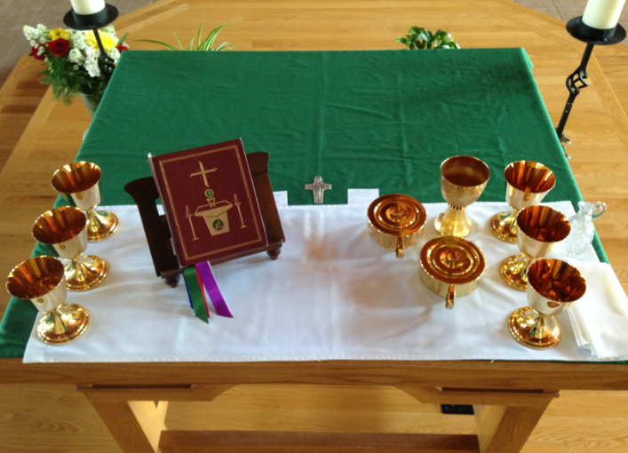

Return to your seats when you are finished.

Step #4 – Receiving the Gifts: When the priest/deacon steps forward to receive the gifts of bread, wine and the collection basket, the servers should follow and stand, one on each side of him.

RM: The priest/deacon will pass you the collection basket to put at the front/side of the altar. When it is time to move, after you placed the basket, go back to the table and get the bowl and towel. Return to the altar and stand by CB.

CB: The priest/deacon will hand you the pitcher of wine. Carefully take it and place it on the altar. Wait for the priest/deacon to pour the water into the wine. As soon as the water is poured, take the small carafe from the altar and hold it until the priest is ready to wash his hands.

Step #5 – Washing Hands:

RM: Hold the bowl and towel for the priest. After washing take the bowl and towel to the table and then go back to your pew.

CB: Pour the water gently over the priest hands. After washing, remove the wine decanter and return it with the water carafe to the table. Return to your pew.

Step #6 - Our Father: During the Our Father,

CB and RM: Go to the altar and join hands with the priest, one on each side of him. Remain there to exchange the Sign of Peace. Go back to your place and share the Sign of Peace with those around you. Please stay in your own area.

Communion Note: CB and RM: will receive communion with the Communion Ministers. Stand toward the front of the platform area next to the Communion Ministers and return to your pew once you have received Holy Communion.

Step # 7 – Clearing the Altar:

RM: Remove the Roman Missal from the altar after you receive communion.
CB: Place the water on the alter
CB and RM: After the communion ministers are finished with communion Father will clean “purify” all the cups. Wait at the alter and Father will give will place them on the end of tha altar when he is done. Take two at a time back to the alter server table. Go back until everything is removed then be seated.

Step #8 – Closing Prayer and Recession:

RM: When the priest stands and says “Let us pray.” Take the Roman Missal and stand in front of the priest. The priest will open the book, hold it while he says the prayer and when he closes it, return to your pew.
After the announcements and during the closing song,

CB: Get the cross from the stand behind the wall, wait there, ready to meet the priest at the steps of the altar when he walks to the front of the church. After the priest bows exit first and walk to the back of the church and place the cross back in its stand.

RM: When the priest starts to exit, go to the front and stand to the right of the priest facing the altar. After the priest bows follow the CB out of the church. Place the Roman Missal on the shelf in the sacristy.

When you return to the sacristy, hang your alb - your server robe - and rope in the closet. Make sure you are careful in hanging them up and button the top button. You are responsible for these robes.

http://www.stmarysfamily.com/altar-server.html
https://www.youtube.com/watch?time_continue=1&v=TSkuJpLVhqM

Thank you for serving!

